The Goods & Services shown are those we can provide to our customers. You may choose only those items you desire. However, any funeral arrangement you select will include a charge for our basic services and overhead. If legal or other requirements mean you must buy any items you did not specifically ask for, we will explain the reason in writing with the statement we provide describing the funeral goods and services you select.
- PROFESSIONAL SERVICES FEE
Services of the funeral director and staff. Our fee for the basic services of the funeral director and staff includes, but is not limited to; staff to respond to initial request for services, arrangement conference with responsible persons for disposition of the deceased; preparation and filing necessary authorizations / permits; recording vital statistics; preparation & placement of obituary notices; coordination with third party providers of other services (ex. cemetery / crematory); (space travel). Also, this charge includes related overhead expenses. $2198.00
This fee for our basic services and overhead will be added to the total cost of the funeral arrangements you select ( This fee is already included in our charges for direct cremation, immediate burials, and forwarding or receiving remains.)
NOTE: Insurance policies are handled as a Courtesy., IF assignable, as those funds are directed to the beneficiary, and NOT the funeral facility !! Some burial societies [ ( Christian. Homeworkers, Neighbors Society ); Gov’t retirement scvs.)].will not submit proceeds to the funeral facility.
We do not accept Policies with a questionable grace period; which are subject to that insurance company’s underwriting..
1. Addition’l Charge --6% fee / Total Insurance $_ _^
2. Coroner Cases --10% fee / Total Insurance $___^

(The % fee will be added to, total of Svcs ) utilizing
Funeral Factor charge, funding immediate svcs ^

Services / shipping worldwide
B EMBALMING ( not required law ) $955.00
Embalming may be necessary, however, if you
select certain funeral arrangements such as a
funeral with viewing. If you do not want embalming
You usually have the right to choose an arrange-
ment that does not require you to pay for it,
such as direct cremation or immediate burial.
1. Mummification (complete Does not include
Sarcophagus /outer container) . $80,009.00
C. OTHER PREPARATION OF BODY
1. Disclosure on Vitally necessary procedures :
Prices below are rates at the point of known contact--- other prices & procedures, may be necessary for containment .

a. Necs’Y Reconstructive restoration(varying rate per hr)
b. Special care of autopzied remains $300.00
c. Washing / Disinfecting of Unembalmed remains $140.00
d. Cosmetology, dressing or placement of the
decedent (In and/or near casket) $180.00

e. Refrigeration Charge for decedents $205.00 daily
In addition to charge referred to,
in section ‘A’. & subsections D4a. G2, G3, G4 ;

D. USE OF FACILITIES AND STAFF
1. Viewing –Visitation / Wake (per day)
Our services include set-up of viewing area,
placement of encased remains, display florals,
memorabilia; supervision & attendance.

a. Washington Slumber room $300.00
b. Holiday--Jarvis Memorial Chapel $500.00 - $6000.00
H-J Chapel seats 250 comfortably, has sound stage
c. Other venues ¹ $500.00 - $6000.00
1 REQUIRES SIGNED WAIVERS

2. Funeral services at Funeral Facility
Our services include coordinating,
supervision of the funeral service, staff for
services, set-up and use of facilities $500.00

.. a. Funeral services at another Funeral Facility ¹
Our services include supervision of
svcs, coordinating, additional staff to
conduct funeral svcs at another facility.
Example .- civic auditorium) $500.00-$ 15,000.00
¹ REQUIRES SIGNED WAIVERS
3. Memorial Services
Memorial services at Funeral Facility.
Our services include coordinating and
supervision of the services, staff , set –
up and use of facilities . $500.00

a. Memorial Service at another Facility. ¹
Our services include coordinating/svcs,
supervision of staff necessary to conduct
svcs at another facility $500.00 - $6000.00
Example ( state park , pavilion )
1REQUIRES SIGNED WAIVERS

4. Graveside Service
a. Our services include use of graveside
equipment, accompaniment of decedent to
cemetery, supervision of graveside service,
staff to attend services. $1300.00--$8800.00

The following are in addition to Section A
5. Jewish Service & accessories $2880.00
6. Candlelite Service ( per 150 ) $500.00
(in addition to Memorial or FuneraI Services)

7. New Orleans Style Band- $2500.00 - $10,000.00 ¹

E. TRANSPORTATION
1. Transfer of remains to funeral facility
a. (within 25 mile local svc radius ) $425.00
b. Outside local radius $ mile market daily rate
c. Medical Examiner case(set by county of origin)

2. Automotive Equipment
a. Hearse ( Locally ) ( 6 hr. rate) per-day $500.00
b. Family Sedan Car (five passenger) $420.08
Locally-- ( 5 hr. rate) per- day
c. Limousine (2 door) local svc $500.00 ( 3 hr. rate)

3. Other Auto Transportation $425.50 (10 hr.=day)
Addidional Drivers -- AVIS, Enterprize , Hertz --- $65 Each
a. Additional charge ( Gratuity included )
b. outside local 25 mile Area $ market daily rate

4. Heritage Elite Horse Drawn Coach ‡ $2450.00up to 3 mi
‡ $2.50 each addtl mile --‡ Each additl hour - $155.00
‡ REQUIRES SIGNED WAIVERS

5. Heritage Military Cassion ‡ $2195.00 up to 3 mi.

6. Celestis Memorial Space Flight $1595.00 - $69,699.00
F. MERCHANDISE
1. Caskets $561.00 - $82,000.00
(Complete list provided separately)

2. Alternative Containers $141.00 - $ 560.00
(Complete list provided separately)

3. Outer Burial Container $200.00 --$27,106.00
(Complete list provided separately)
4. URNS $105.00 - $2183.00
5. Military Gear (Veterans ) $125.00 - $695.00
6. STATIONERY
a. Acknowledgement Cards
standard ( style A- (per 25 cards)( no charge with services)
(style B (per 25 cards) _$_____.__
b. Register Book
standard ( style A) - (quantity 1 ) (no charge with services)
(style B) Engraved wood $195.00
(style C) Linen (picture frame) $ 68.00
- MEMORY Folders (per 200) $195.00
8½ x 11 )printed with color ( per side ) $1.08
c1. (11 x 17 ) printed/color ( per side ) $1.59

d. Prayer Cards $______. _
standard(50)------------no charge with service

7. BURIAL CLOTHING $190.00 - $750.00
Linen slightly higher

8. MONUMENTS
.Mausoleums -Granite- North American -Made
1. (Single style) Flat Roof- Grey/(Blue Ridge) -------$ 13,498.00
Other Colors- Tx. Imperial 25,301.-- Dakota Mahogany-$31,506.--Am. Black -$34,000.

2. (Double style- Gable Roof- Grey/(Blue Ridge) ---$ 32,559.00
3. Three persons crypt style Flat Roof- Grey/(Blue Ridge) --Side – by – side

3 person --- $ 39,990.0
4. Four persons crypt style Flat Roof- Grey/(Blue Ridge) - $ 46,743.0
5. Six persons crypt style - Flat Top- Grey/(Blue Ridge) - $ 59,908.0
6. Eight person crypt style - Flat Top- Grey/(Blue Ridge) - $ 87,009.0
7. 10 person crypt style - Flat Top- Grey/(Blue Ridge) -----$ 150,789.0

Foundations included; some require Building permits

Manufacturers available Personal Fortress Mausoleum--------available overnight

G. Special Services___
1. Forwarding remains to Funeral Facilities.
This charge includes necessary services of staff,
embalming, necessary authorizations, removal
of the decedent and local transportation to
the airport. This charge does not include visitation,
rites or ceremonies, prior to forwarding of the body.

a. With minimum shipping container $ 3954.00
b. W/ casket selected from our funeral facility
(in addition to cost of the casket) $ 3578.00
c. With Air Tray (airport cost + cash advance)
1. ( IAH)→ $ 4354.00
2. Austin Airport→ $ 4403.00
( Svss currently not available from B/CS—Possibly ( JUNE 2025 )

2. Receiving remains from Funeral Facilities.
This charge includes temporary shelter of decedent, direct transportation to the cemetery - 25 miles (twenty-five mile radius) and necessary services of staff, in our facility; exclusive of embalming or other preservation techniques !
This charge does NOT include visitation, attendant rites or ceremonies !!
[( via ( IAH houston )]→ $ 2598.0
[( via ( AUS austin )]→ $ 2748.0
[( via ( D-FW )]Dallas-FtWorth → $ 3295.0
[( via ( SATX )] San Antonio → $ 3380.0
Svcs currently not available from B/CS--- ( begin June - 2025 )

3. IMMEDIATE BURIALS
Does not include Gravedigging svs ( generally $1300.00 )
Our charge for an Immediate burial, without any attendant rites or ceremonies; includes removal ( 25 Miles Radius ) & shelter of decedent,----(does NOT include Embalming nor other preservative techniques ) BUT, staff for local transportation to final destination (25 Miles radius) & authorizations.
A. Immediate burial with merchandise provided by purchaser
$2623.00

B. Immediate burial w/Particle Board BURIAL container. $3184.00

C. Immediate burial w/Cloth casket - Ex.-Unity or Emerson (starmark) $3453.00
D. Immediate burial; casket selected from our facility;
This fee is in add’t. to the cost of casket $ 2623.00

NOTE If an immediate burial service, requires more than 24 hrs shelter of remains, a $100.00 (one hundred charge per day, up to two days (48 hours), goes into effect & after two days, decedent’s are handled in accordance with laws, prescribe.
Notice*** No refund or credit will be issued for package sale goods or services which remain unused by the customer at the time of need.

4. DIRECT CREMATION

NOTE: Crematory reserves the right to charge nominal fee of $100.00 per, 100 pds., over the wgt--300 pds !

Our charge for direct cremation, without any attendant rites or ceremonies, Includes removal of decedant, local transportation to crematory, necessary services of staff and authorizations.
If you want to arrange a direct cremation, you can use an alternative container, which can be made of materials like fiberboard or composition materials (with or w/o an outside covering).
We can provide: Cremation Boxes & Alternative Containers.

At – Need ---- This Schedule Pricing

This Schedule DOES NOT Include a Crematory Fee, ( GENERALLY $395.00) which MAY- be , in-dependent of the Local Crematory , outside of local area, 25 miles radius, @ time of Need !!!! TOTAL $ 2042.00

A. Direct Cremation w/ Container Provided by Purchaser $1497.00 ( Pay Cash (At-Need); receive a $61.00 Discount-At -Need Only )

At – Need Only
B. Direct Cremation w/Cremation Tray $1647.00
No Discount available with #G4B or #G4C

C. Direct Cremation w/alt. cremation container
Heavy Cardboard ( Will hold up to 275 pds ) $1843.00
----- At Need Only ----

D. Direct Cremation with casket selected from facility.
Pay Cash ( At-Need); receive a $61.00 Discount
(At Need Only) $1497.00
NOTE: This Fee added to cost of the casket)

NOTE State Laws of Texas require the decedent NOT be
cremated within forty-eight hrs., after pronounced deceased. Temporary shelter of the remains are included in the above direct
cremation price, for the required 48 hr. time line,
ONLY !! A State official or authorized Medical official, can authorize a shorter length of time between death & direct cremation, because of Infectious disease or religious considerations.

E. Direct Cremation, Special privileges viewing
Fee Determined by crematory @ time of Need.

5. Charges PER HOUR for staff services and /or
use of facilities for partial ceremonies, body donations or other
items not included elsewhere on this general price list.-minimum
$ 200.00 per hr.

Pictured: Lazer - engraved Granite
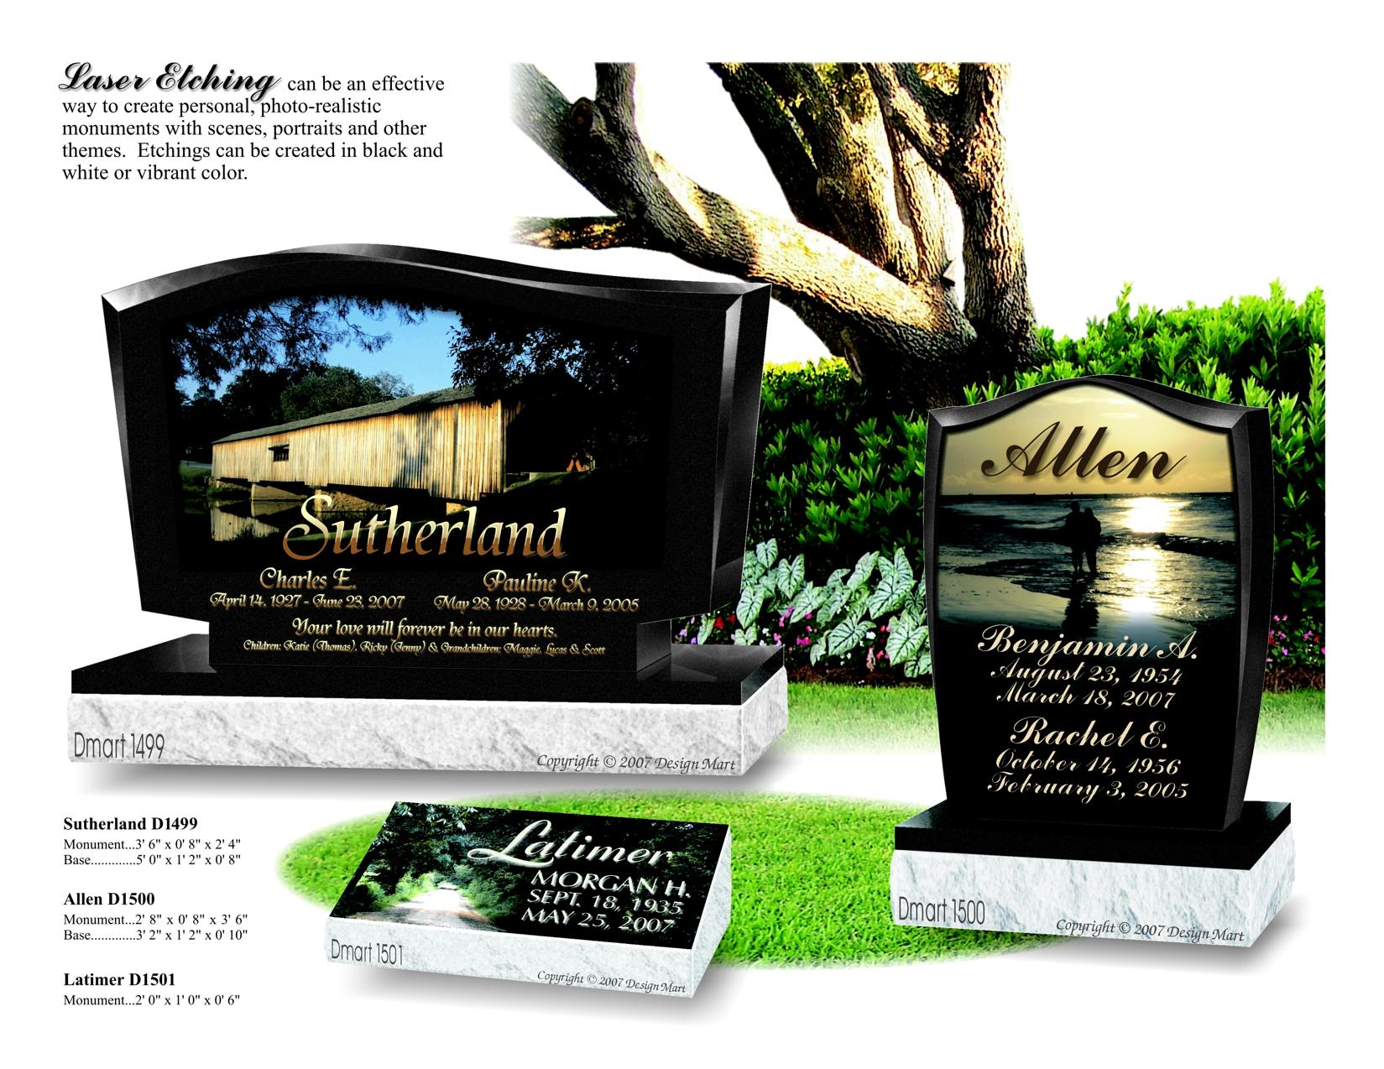
Sutherland style = $7,186.00 Allen style – $ 4378.
Latimer = $ 1343.00

MONUMENTS
.Mausoleums -Granite- North American -Made
1. (Single style) Flat Roof- Grey/(Blue Ridge) -------$ 13,498.00
Other Colors- Tx. Imperial 25,301.-- Dakota Mahogany-$31,506.--Am. Black -$34,000.

2. (Double style- Gable Roof- Grey/(Blue Ridge) ---$ 32,559.00
3. Three persons crypt style Flat Roof- Grey/(Blue Ridge) --Side – by – side

3 person --- $ 39,990.0
4. Four persons crypt style Flat Roof- Grey/(Blue Ridge) - $ 46,743.0
5. Six persons crypt style - Flat Top- Grey/(Blue Ridge) - $ 59,908.0
6. Eight person crypt style - Flat Top- Grey/(Blue Ridge) - $ 87,009.0
7. 10 person crypt style - Flat Top- Grey/(Blue Ridge) -----$ 150,789.0
Includes 10”-18” Foundations….. some MAY require building permits

```````````````````````````````    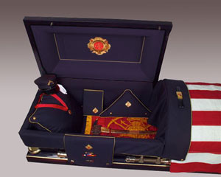 


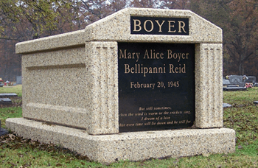
Fortress Mausoleum-
Available overnight
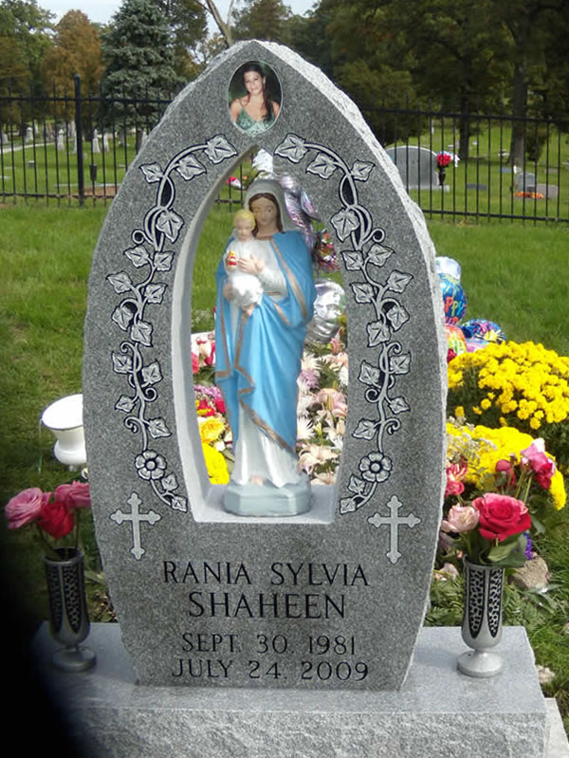
Other models available

Ashford & Oliver Mortuary
tm

Trademark protected

GENERAL PRICE LIST

Ashford & Oliver
Mortuary
and the
Holiday - Jarvis Memorial Chapel
1201 Farquhar Street
Navasota, Texas
77868 – 4235

Tele # 936-825 2525
onlineFax

Email: mortuary-cremations@hotmail.com

These prices are effective as of

December 25, 2024

but are subject to change
January 01, 2025
without prior notification

website
ashford–olivermortuary.com
ashford-olivermortuary.com

